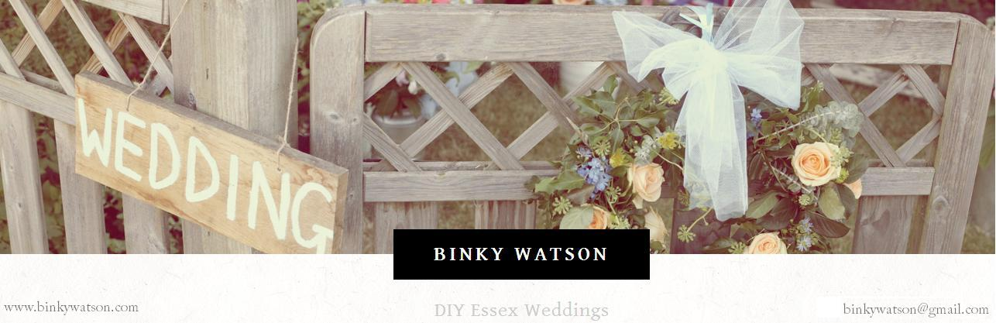

Contract of Hire

Vintage China, Glassware

Terms & Conditions
Hire Period
Our weekend hire period is Friday to Sunday/Monday. We will arrange this with you closer to the date of your event.
Delivery/Collection
We can offer a delivery and collection service within a reasonable distant at an extra cost. Alternatively, our vintage china and glassware can be collected and returned free of charge.
Deposit
We require a 50% deposit as confirmation of your order which is non-refundable.
Payment
All payments should be made via bank transfer to or paypal.
The final balance is payable no later than 7 days before the date of your event.
Faults
Any faults to be notified to Binky Watson within 2 hours of receipt. During the hire period the hirer takes full responsibility for breakages and loss until received back by Binky Watson.
Crockery Care
It is expected that due to the age and vintage nature of the items, some of the pattern and gild edges may be worn with age. All items are STRICTLY HANDWASH ONLY. Should the crockery not be fully cleaned to a state that we are able to immediately loan it out again, an admin fee (from £20) will be charged if we need to re-wash your order.

Safe Packing
Once properly hand-washed and dried, please package the crockery as it was when it was delivered in the packaging provided by Binky Watson. The cups are coloured coded on the bottom so that they are kept in their boxes in order to match them up.
Refundable Breakage Deposit
A refundable damage cash deposit is required which will be returned via bank transfer upon the safe return of our china and glass (please supply your bank details below). Please see below for breakage costs. These costs will be deducted from the refundable breakage deposit or payable to us if these costs exceed the agreed amount. This is to be paid on the collection/delivery of the crockery.
Damages/Losses/Breakages will be charged at the following costs:
£6.00 per trio (or any part of)
£3.00 per side/dinner plate
£0.50 per piece of cutlery
£4.00 per milk jug, sugar bowl, small glass bowl
£15.00 per teapot
£10.00 per sandwich/cake plate
£10.00 per cake stand
£1.00 per wine, champagne, 1/2 pint, pint glass
£POA all other items
We take no responsibility in the event of any injury or damage caused by the hired equipment, however caused.
Cancellation
If you change your mind, please let us know ASAP. Cancellation will be 100% of the crockery hire value if cancelled within 28 days of your event.
Please complete a sign below with all confirmed details.

